# CS 255 System Design Document

Andre Burton

09 August 2023

## UML Diagrams

### UML Use Case Diagram

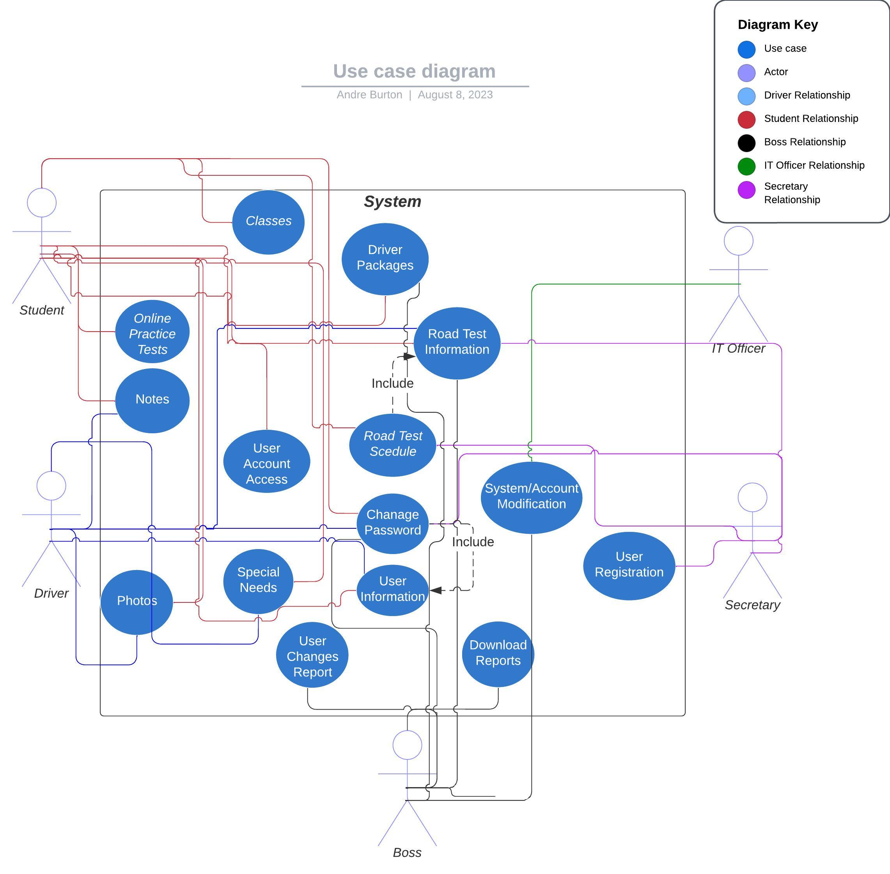

### UML Activity Diagrams

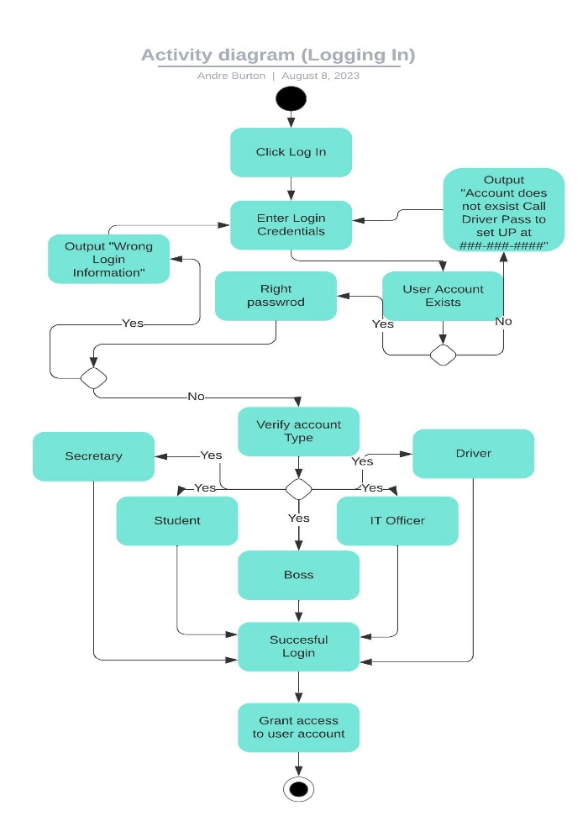

### UML Sequence Diagram

### UML Class Diagram

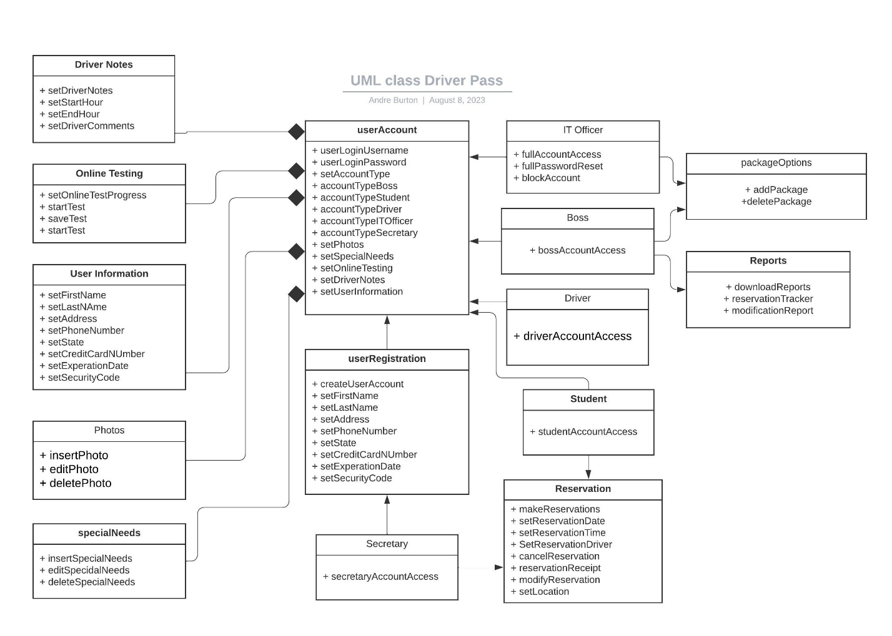

## Technical Requirements

*Hardware*

*IT Officer/ Boss*

* *Internet connection*
* *Storage drive for offline files/system backups*
* *Computer with access to modern search engines*
* *Monitor is not using laptop*
* *Mouse*
* *keyboard*
* *Server to hold program database.*
* *Ups device to prevent data loss.*
* *Payment processing station*
* *Router/modem*
* *Ethernet cables*

*Other Users*

* *Internet Connection*
* *Computer with access to modern search engines*
* *Monitor is not using laptop*
* *Mouse*
* *Keyboard*
* *Phone’s*
* *Router/modem*
* *Ethernet cable’s*

*Software*

* *Security software*
* *Backup tool software*
* *Proper IDE software*
* *Modern Search Engine*
* *Debugging software*
* *Cloud Based Software*
* *Payment processing software*

*Tools*

* *Computer with hardwire connection.*
* *Debugging tools*
* *Security badges for workers*

*Infrastructure*

* *Building to house company and servers*
* *Proper electrical work to keep up with company usage*
* *Proper wireless and wired connections*
* *Physical security measures (locks, cameras. Sensors)*
* *Workstations*
* *Parking areas*